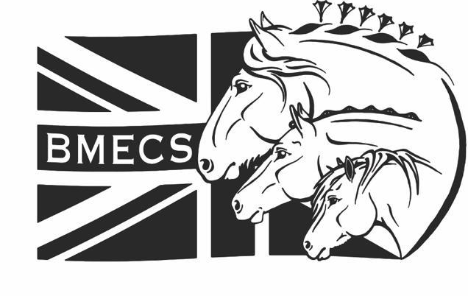
British Model Equine Championship Show 2023
Application for Judges and Stewards
30th September & 1st October
Thank you for your interest in volunteering as a judge or steward for BMECS 2023. Please complete the following application, so that we can match the best candidates with their ideal divisions. You do not have to be an entrant/vendor in order to judge at BMECS. If you are volunteering to help on a day you are also showing/vending, we suggest that you have a helper. Judges will be compensated with a special gift.
Judging Application
Forename:
Surname:
Email (please ensure this is one that you check regularly):
Are you showing at BMECS 2023 | Yes/No
Are you vending at BMECS 2023 | Yes/No
Are you at least 18 years old? | Yes/No
Emergency contact name & number:
Three Judging/Stewarding References: Please include show name, approximate date, and showholder’s name | 1.  2.  3.
Please tell us a bit about your judging or stewarding experience, model and real horse knowledge, judging style and placement priorities, favourite sections to judge and why – basically, why you should be chosen as a BMECS 2023 judge. Please use as much space as you need.

Please indicate which divisions you will be showing in (Yes/No), and your judging/stewarding preferences. You may not judge a division in which you, or a family member, are showing. Please order your judging preferences, with “1” being your first choice. If you would prefer to steward a section rather than judge, please write “Steward”.

SATURDAY Showing Judging Pref Showing Judging Pref
CTF Plastic: |  |  | OF Plastic:
CTF Other: |  |  | Performance:

SUNDAY Showing Judging Pref Showing Judging Pref
Custom: |  |  | Artist Resin:
Workmanship: |  |  | Artist China:
Animal Artistry: |  |  | CCR:

Please email this form to britishmodelequinechampionship@gmail.com by no later than
4th September.
Successful candidates will be contacted to discuss judging assignments no later than 18th September.

