East Dorset Live Show 14th May 2017 - Results

Performance Section

P1. English Ridden H/P
1. CRS Beautiful Song – CH
P2. Western Pleasure
1. WS Jasper – JR
2. Sheza Golden Girl - DP
3. AS Hidden Dragon - DH

P3. English Performance – Jumping
1. WS Superman - JR
2. Merlot - DP
3. Cabernet - DP
4. Dorset Knob - MW
5. Brigadier - LN
6. Benjy - HD

P4. English Performance - Non Jumping
1. WS Blueberry - JR
2. A Winning Ticket - CG
3. ???
4. Crackers - CH
5. ‘Those were the days’ – MW

P5. Western Performance
1. WS Sheza Gotta Fly! - JR
2. CRS Sunshine - CH
3. AS Hidden Dragon - DH
4. Burning Flame - LN
5. ???
6. Patchy Prina - EL

P6. Other Ridden/Performance
1. WS Elum - JR
2. Midnight Magic - ???
3. ???
4. Mad Max Scene - ???
5.???
6.???

P7. Costume/Fancy Dress
1. Princess Blanche - MW
2. Jamilia - HD
3. ???
4. FCS Silver Sultan - DH
5. ???
6. ???

P8. Scene/Other not listed
1. Gloria - MW
2. “Running out of Room” - JR
3. ???
4. Pokemon Scene - SB
5. AS Hidalgo - DH
6. AS Mobon Llyr – DH

Performance Champion
Gloria - MW
Performance Reserve Champion
WS Jasper - JR
Performance Res to Res Champion
WS Blueberry - JR

OF Section

A1. Arab
1. Zuleita - DJ
2. CRS AK AI Sunua - CH
3. Rhapsady in Black - LN
4. ???
5. Afraid to Love - SP
6. FCS Silver Sultan - DH

A2. TB
1. Chief Avenging Hawk - DJ
2. He’s a Charmer – SP
3. Snowy Blues - SB
4. Frankel - HD
5. Joley Bay - MW
6. Darkest Dream - EL

A3. Part Arab/AA/PBTB
1. FCS Faith - DH
2. Made ya Look - SB
3. ???
4. Honeybun - HD
5. Profit - ???
6. FCS Masood - DH

A4. Heavy Horse
1. Metamorphosis - JW
2. Whipped Delight - SB
3. One in a Million - SB
4. Pandora Spox - DJ
5. Big Boris - EL
6. Glenelg Giant II - MW

A5. WB/Sporthorse
1. Smart + Speedy - EL
2. Breaking Dawn - JW
3. Bay Solitaire - MW
4. Wildest Dreams - SP
5. Ariella - ???
6. Breitling - SB

A6. Iberian
1. WS Alborozo - JR
2. Handsome Harry - EL
3. AS Barry - DH
4. Kripton Seni II - LN
5. Funny Side - SP
6. Quicksilver - MW

A7. American Stock
1. TieTae - DJ
2. Platinum Boy - HD
3. Arizona Sunset - SP
4. Apache Storm - SP
5. Devine Design - SB
6. Champagne Wishes - SB

A8. American Other inc Gaited
1. CRS The Living Desert - CH
2. Blue By You - MW
3. AS Sweet Dreams - DH
4. Udvarhely Miricle - JW
5. Sacramento - JW
6. Mr President - MW

A9. British Native Pony
1. Knight Rider - SB
2. Penrhyn Brecon - JW
3. Skye Taffy - JW
4. ???
5. Sneak Preview - SP
6. Tomb Raider - SP

A10. Other Purebred Horse
1. Thunder and Roses - SB
2. CRS Peace of Mind - CH
3. Gentlewulf Radarson - DJ
4. Golden Moment - EL
5. PS. I Love You - SP
6. Girls Night Out - SB

A11. Other Partbred Horse
1. Smug Juggler - DJ
2. CRS Black Window Dawn - CH
3. ???
4. Fools Gold – EL
5. ???
6. Turnbridge – Wells - SB

A12. Other Pony Pure
1. AS Ævarr - DH
2. Frozen Spirit - SP
3. ???
4. Magical Light - SB
5. ???
6. Whispering Spirt - SP

A13. Other Partbred Pony
1. Satan’s Promise - SP
2. Forest Flames - SP
3. Barry Bang Blue - SB
4. Dun Deal - FL
5. ???
6. Bertie - LN

A14. Longears/Exotic
1. Letchworth Lucy - DJ
2. Henrietta - DP
3. Juliette - JW
4. ???
5. Fandango - DJ
6. Guy - MW

A15. Foals/Youngstock
1. Stolen Heart - HD
2. Heartbreaker - LN
3. Diamond Flame - SP
4. Passion Princess - SP
5. High in the Sky - SB
6. Across the Bay - SB

OF Champion
WS Alborozo - JR
OF Reserve Champion
Chief Avenging Hawk - DJ
OF Res to Res Champion
Thunder and Roses – SB

CM Section
B1. Arab
1. Ruchbah - DP
2. Kisses in the Moonlight - SP
3. Juliets Rose - MW
4. Shattarn - ???
5. Blue Sapphire - LN
6. ???

B2. TB
1. CRS – Acorn’s Economy - CH
2. Malice Aforethought - DP
3. ???
4. ???
5. Ruffian - LN
6. ???

B3. Part Arab/AA/PBTB
1. Flo Jo – DP
2. FCS Illusion - DH
3. ???
4. Burras Bravado - DJ
5. Galaxy Star - LN
6. ???

B4. Heavy Horse
1. Accalia - LN
2. CRS Der Gruftwatcher - CH
3. Darius - MW
4. ???
5. ???
6. ???

B5. WB/Sporthorse
1. CRS Baywatch - CH
2. Putting on the Ritz - DP
3. Arco - DP
4. ???
5. Love Story - SP
6. Eye of the Tiger - SP

B6. Iberian
1. Phonix Rising - SB
2. AS The Nine Circles of Hell - DH
3. AS Emidio Bajardo - DH
4. ???
5. Forest of Shadows - LN
6. ???

B7. American Stock
1. AS Hidden Dragon - DH
2. Tequila Sunrise - SB
3. Luca’s Intentions - SP
4. Aftershock - SB
5. Camo Girl - MW
6. ???

B8. American Other inc Gaited
1. CRS Acapello - CH
2. CRS Crying Icicles - CH
3. Ghost Spirit - LN
4. OH em Gee - DP
5. Wowza - DJ
6. AS Gris Oso – DH

B9. British Native Pony
1. CRS God’s Nector - CH
2. Who’s Afraid - DP
3. Wheddon Cross Woodpecker - JW
4. ???
5. ???
6. AS Black Ice - DH

B10. Other Purebred Horse
1. Storm Chaser - SB
2. Cocktails at Dawn - SB
3. ???
4. Fancy Boy - LN
5. Staring in Space - LN
6. ???

B11. Other Partbred Horse
1. Mister Sunshine - HD
2. AS Victor Valentino - DH
3. ???
4. ???
5. Charcoal - MW
6. Jupiter Star - HD

B12. Other Pony Pure
1. Reykjavik - DP
2. AS Evarr - DH
3. AS Dante - DH
4. ???
5. Zodiac princess - SP
6. Stay the Night - SP

B13. Other Partbred Pony
1. AS Euria Abene - DH
2. CRS Not Now Cato - CH
3. ???
4. AS Biscuit - DH
5. ???
6. ???

B14. Longears/Exotic
1. Dorothy - DP
2. Daisy - MW
3. ???
4. ???
5. ???
6. ???

B15. Foals/Youngstock
1. Cheeky Charlie - SP
2. Aria Aremosa - DJ
3. ???
4. Dusty Miller - DJ
5. ???
6.???

CM Champion
CRS God’s Nector - CH
CM Reserve Champion
AS Hidden Dragon - DH
CM Res to Res Champion
Reykjavik - DP

Artist Resin/Artist China Section
C1. Arab
1. CRS Ana Bababa - CH
2. Mahfouz - DP
3. ???
4. AS Emir el Laheeb - DH
5. ???
6. ???
C2. TB
1. Black Cohosh - DP
2. CRS Peace Zone

C3. Part Arab/AA/PBTB
1. Dancing With Wolves - SB
2. CRS Debanni - CH

C4. Heavy Horse
1. CRS Heinrich Hanson – CH
2. WS Cowboys Revenge - JR

C5. WB/Sporthorse
1. CRS Undercliff – CH

C6. Iberian
1. Royal Revenue - SB
2. White Sox - MW

C7. American Stock
1. Spot me on an Appy - DP
2. Ponderosa - DP
3. Lady Sings the Blues - JW
4. Aspects of Love - SP

C8. American Other inc Gaited
1. Days of Wine & Roses - MW
2. The Chocolatier – MW
3. AS Pipsqueak - DH
4. ???
5. ???
6. Royal by Design - JW

C9. British Native Pony
1. Penrhyn Golden Ticket - JW
2. Penrhyn Cosmic Storm - JW
3. Fairfield Della - DP
4. AS Elven Dreams - DH
5. Santa’s Surprise - DJ
6. ???

C10. Other Purebred Horse
1. Scaramouche - DJ
2. Kiss from a Rose - DP
3. New Romantis - SP
4. ???
5. Aztec Camera - DP
6. Moon Dancer – MW

C11. Other Partbred Horse
1. Update - DJ
2. CRS Grumpy Cat - CH
3. The Barrister - DP
4. Mayer’s Memory - JW
5. ???
6. ???
C12. Other Pony Pure
1. AS Thor’s Cauldron - DH
2. CRS Melheveien - CH
3. ???
4. ???
5. ???
6. ???

C13. Other Partbred Pony
1. CRS I Am Legend - CH
2. CRS Eirin - CH
3. Gwydion - DJ
4. Foxkerry Ttrintinos Blues - SB
5. ???
6. AS Danger! Danger! - DH

C14. Longears/Exotic
1. Josephine - MW
2. AS Calliope - DH
3. ???
4. ???
5. ???
6. ???

C15. Foals/Youngstock
1. Daisy Duke - DP
2. AS Jack be Nimble - DH
3. Rusty Nail - DP
4. Groovy Gummybear - SP
5. Funky Jellybean - SP
6. ???

AR/AC Champion
Days of Wine & Roses - MW
AR/AC Reserve Champion
Scaramouche - DJ
AR/AC Res to Res Champion
AS Thor’s Cauldron - DH

CTF Section
D1. Arab
1. Snowy - SB
2. Nabg - JW
3. Jewel - SB
4. One Last Dance - LN
5. One Last Time - LN
6.???

D2. TB
1. CRS Incident Officer - CH
2. Royal Secret - LN
3. Toy Boy - DJ
4. Ninja - LN
5. Poppy - MW
6. ???

D3. Part Arab/AA/PBTB
1. CRS Midas Rex - CH
2. CRS Enchanted Songdance - CH
3. Shantih - LN
4. ???
5. ???
6. ???

D4. Heavy Horse
1. WS Bay Shire - JR
2. Oldfield Rosie - JW
3. Bubba Gump - MW
4. Unnamed Percheron - JW
5. ???
6. Colour my Life - SB

D5. WB/Sporthorse
1. Sweet Dream - LN
2. El Santo - DP
3. WS Bay WB - JR
4. ???
5. ???
6. Spot - SB

D6. Iberian
1. Wisteria Witch - MW
2. Siglavy Europa - JW
3. ???
4. ???
5. Buenos Dias - LN
6. Land of Hope - SB

D7. American Stock
1. Spotty Bum - DP
2. Burning Flame - LN
3. ???
4. ???
5. Paint me Colour - SB
6. ???

D8. American Other inc Gaited
1. AS Dream Big - DH
2. Hank Boliday - MW
3. Splurge - DJ
4. ???
5. AS Cappuccino - DH
6. ???

D9. British Native Pony
1. Dunsford on Ice - JW
2. Dunsford – Bolero - JW
3. Prince Caspian - MW
4. ???
5. Crunchie - SB
6. Wizzy – DJ

D10. Other Purebred Horse
1. Diecinueve - JW
2. Sjoerd - DP
3. Unnamed Friesian - JW
4. ???
5. Two Minutes to Midnight - MW
6. Tornado Warning - LN

D11. Other Partbred Horse
1. Unnamed Gypsy Mare - JW
2. CRS Grey Goose - CH
3. ???
4. Unnamed Stallion - JW
5. ???
6. ???

D12. Other Pony Pure
1. CRS Charles Dickens - CH
2. High Flyer - JW
3. Silver Hollow - JW
4. Storm - SB
5. Sandy Hollow - LN
6. Reifner - JW

D13. Other Partbred Pony
1. Petal Power – MW
2. CRS Y Deryn Pur - CH
3. ???
4. ???
5. ???
6. ???

D14. Longears/Exotic
1. Babette - MW
2. Maisy - DP
3. ???
4. ???
5. ???
6. Racing Stripes - SP

D15. Foals/Youngstock
1. Marble Lake - LM
2. AS Roo - DH
3. Peanut - MW
4. Earl - DJ
5. Tilly Trot - MW
6. SuperNova - SB

CTF Champion
CRS Charles Dickens - CH
CTF Reserve Champion
AS Dream Big - DH
CTF Res to Res Champion
Unnamed Gypsy Mare - JW

Fun Classes
A - Performance/Scene Dragons
1. ‘Chestnut Mare’ - CH
2. Dragon Jump - MW

B - OF Resin Dragons
1. WS Snuff - JR
2. ‘Dragon - SS

C - OF Other Dragons
1. Red Glass Dragon - ???
2. Purple Dragon - JR

D - CM Dragons – No entries

E - Fantasy – Equines
1. Decorator PS Arab - ???
2. Thestrel - JR

F - Fantasy – Non-Equine
(did this become other animals?)
1. Pink Pig & Friends - ???
2. Koala & Friends - ???
Knob Throwing Game
Champion Tosser – Shaun Small
Pin the Knob Game
Champion Knob Pinner – Mary Winkler

---------------------------------------------------------------

Supreme Champion
CRS God’s Nector - CH

Reserve Supreme Champion
AS Hidden Dragon - DH

Res to Res Supreme Champion
WS Alborozo – JR

---------------------------------------------------------------

Entrants: ------------------
Elizabeth Larcombe - EL
Holly De La Haye - HD
Sebastian Park - SP
Dorothy Jacobs - DJ
Diane Pike - DP
Mary Winkler - MW
Catriona Harris - CH
Laura Niedomagale - LN
Siena Burnett - SB
Jody Wheeler - JW
Dani Hunt - DH
Jackie Radwanski – JR
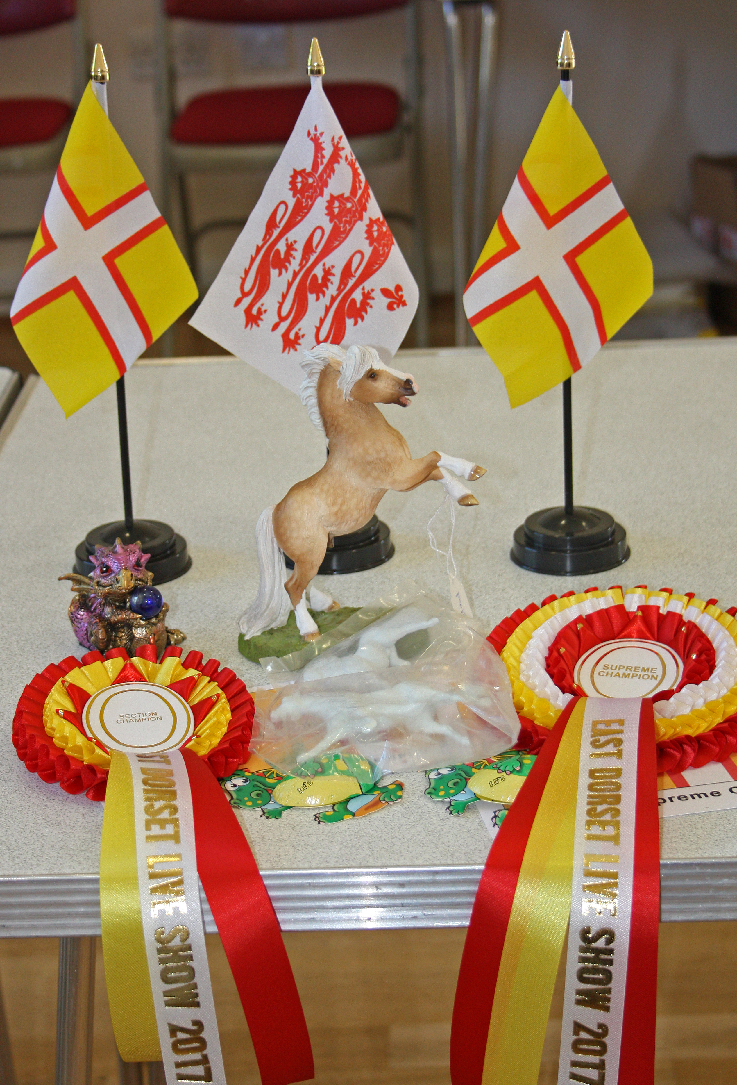

The Raffle + extra donations raised an amazing £100 for Margret Green Animal Rescue.
Thank you to everyone who donated raffle prizes and brought raffle tickets ☺
Thank you to all the judges and everyone who helped out with the show, your help is very much appreciated.

East Dorset Live Show 2018 …?
Watch the FB group for updates ☺

Thank you very much for supporting
East Dorset Live Show 2017.
Best Wishes
Jackie Radwanski x

